# **Staffing Dashboard**

This dashboard provides an essential overview of your project's staffing status and total count.

**Table: Detailed Order View**

* **Contract Number:** Unique identifier for tracking the order.
* **Party Name:** Likely the company or individual the staff is assigned to.
* **Status:** Shows the order's current stage (e.g., Active, Draft).
* **Contract Type:** Specifies if staff are employees, contractors, etc.
* **Start/End Dates:** Defines the staffing period.
* **Organization Name:** The internal department the staff belongs to.
* **Currency and Legal Entity:** Important for billing and legal compliance.

**1. Order by Status- Active**

Order by Status -Active tile approach aims to present a comprehensive overview of the number of contracts under the **Active** status category.

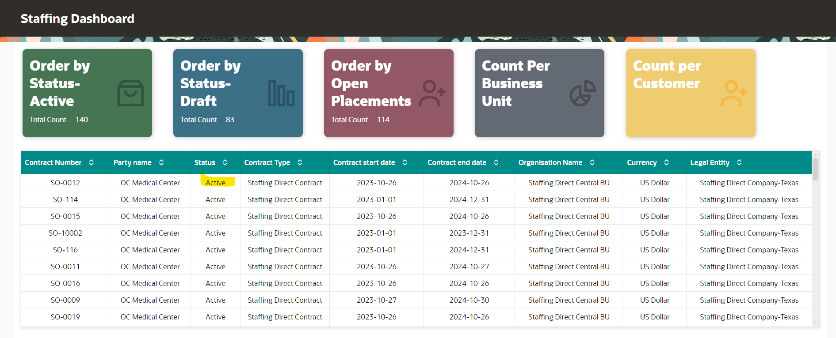

**2. Order by Status- Draft**

Order by Status- Draft tile gives you a summary of all the contracts that are in the **Draft** stage.

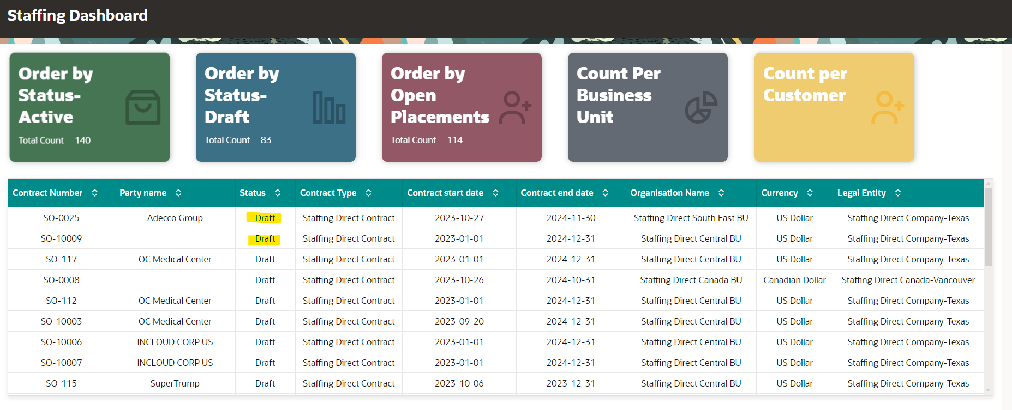

**3. Order by Open Placement**

Order By open Placement tile provides an overview of the contracts that are available for the placement.

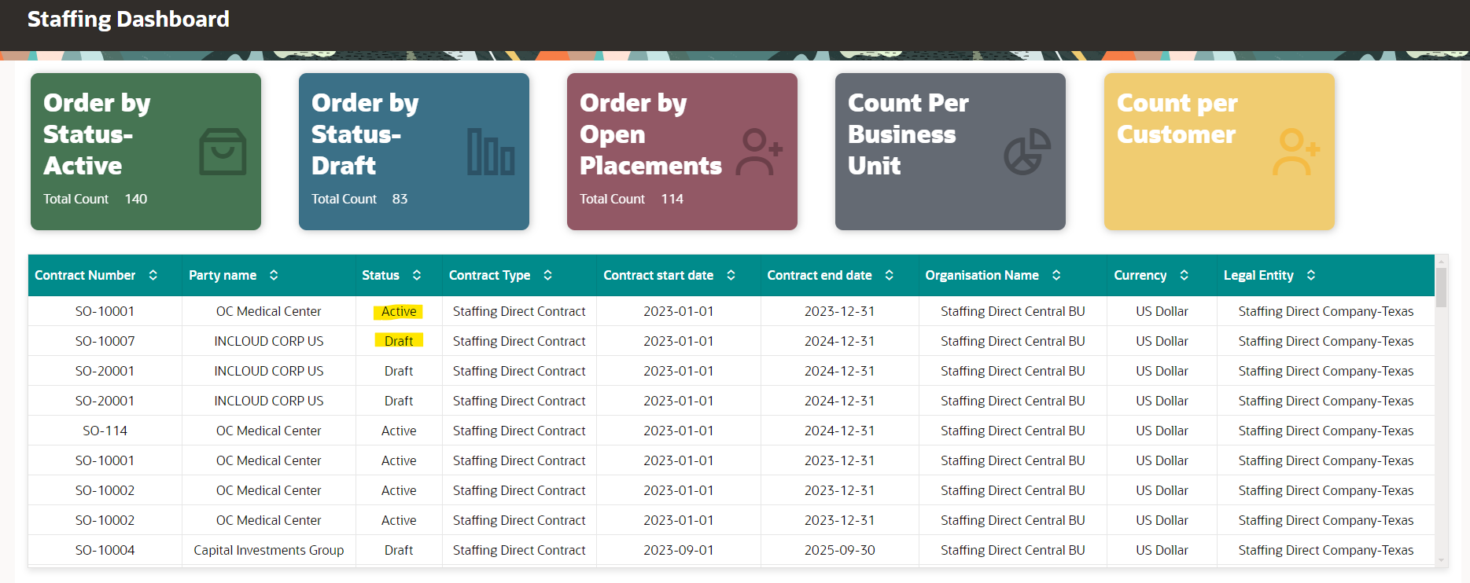

**4. Count Per Business Unit**

Count per business unit provides you the total number of contracts categories by business unit. The contracts outline under that particular business unit can be accessed by clicking on it specifically.

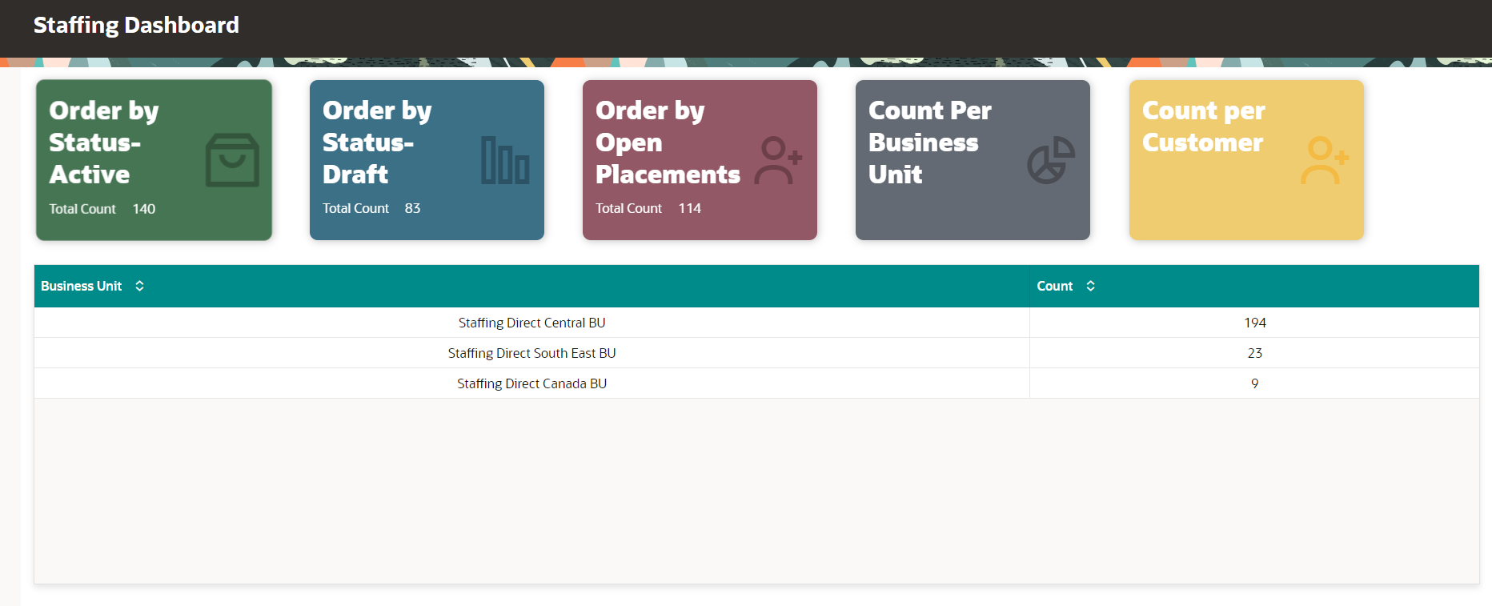

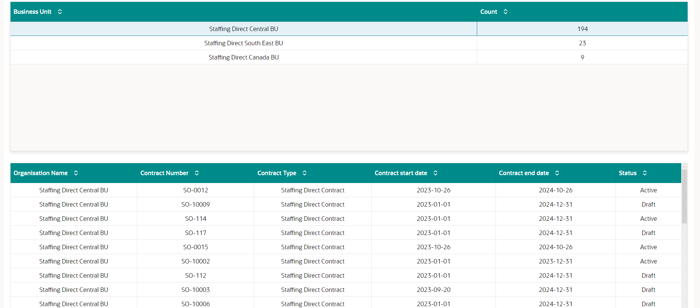

**5. Count Per Customer**

Count per customer tile approaches the total count of contracts according to customer name. User can view the details of the contracts by clicking on the specific customer.

